Exam Choice  2007  TRIAL HIGHER SCHOOL CERTIFICATE EXAMINATION  Chemistry  General Instructions  - Reading time – 5 minutes  - Working time – 3 hours  - Write using black or blue pen  - Draw diagrams using pencil  - Approved calculators may be used  - Write your student number in the space provided | Student Number  Total marks – 100  Section I Pages 2 - 18  75 marks  This section has two parts, Part A and Part B  Part A – 15 marks  - Attempt Questions 1-15  - Allow about 30 minutes for this part  Part B – 60 marks  - Attempt Questions 16-28  - Allow about 1 hour and 45 minutes for this part  Section II Pages 19 - 28  25 marks  - Attempt ONE Question from Questions 29-33  - Allow about 45 minutes for this section

Section I
75 marks

Part A – 15 marks
Attempt Questions 1-15
Allow about 30 minutes for this part

Use the multiple-choice answer sheet.

Select the alternative A,B,C or D that best answers the question. Fill in the response oval completely.

Sample: 2 + 4 = (A) 2 (B) 6 (C) 8 (D) 9

A B C D

If you think you have made a mistake, put a cross through the incorrect answer and fill in the new answer.

A B C D

If you change your mind and have crossed out what you consider to be the correct answer, then indicate the correct answer by writing the word correct and drawing an arrow as follows.

A B C D

correct

1 What is the catalyst used to hydrate ethylene?

- zeolite
- yeast
- iron/iron oxide
- dilute sulfuric acid

2 Which of the following is true about current research into biopolymers?

- It has resulted in polymers which biodegrade when disposed of.
- It has resulted in the widespread adoption of biopolymers by industry.
- It has resulted in polymers less expensive than those from petrochemicals.
- It has resulted in polymers with exactly the same properties as those from petrochemicals.

3 Polyethene (polyethylene) is an extremely important polymer, available in two general forms-high density polyethene (HDPE) and low density polyethene (LDPE). Which of the following statements about polyethene is correct?

- HDPE is branched and has a lower melting point than LDPE.
- HDPE unbranched and has a lower melting point than LDPE.
- LDPE is branched and has a lower melting point than HDPE.
- LDPE is unbranched and has a higher melting point than HDPE.

4 Phosphorus-30 is produced by bombarding aluminium-27 with alpha particles. Which of the following nuclear equations correctly represents this?

- 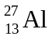+ 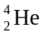→ 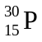+ 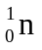
- + → 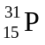
- 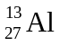+ 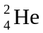→ 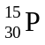+ 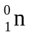
- + 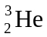→
5 Which of the following reactions is a redox reaction?

- KOH(aq) + HCl(aq) → KCl(aq) + H₂O(l)
- Cu(s) + 2AgNO₃(aq) → Cu(NO₃)₂(aq) + 2Ag(s)
- 2NaCl(aq) + Pb(NO₃)₂(aq) → PbCl₂(s) + 2NaNO₃(aq)
- H₂SO₄(aq) + K₂CO₃(s) → K₂SO₄(aq) + H₂O(l) + CO₂(g)

6 Which of the following lists contains substances which are in order of increasing boiling points?

- ethanol, ethene, ethane
- methanol, ethane, propanol
- propanol, ethanol, methanol
- methane, methanol, methanoic acid

7 The pH of a sulfuric acid solution is measured at 2.0 by a pH meter.

Which of the following alternatives shows the correct concentrations of hydrogen and sulfate ions in this solution?

 | Concentration of hydrogen ions in solution (M) | Concentration of sulfate ions in solution (M)
A | 1.0 x 10⁻¹ | 2.0 x 10⁻¹
B | 1.0x 10⁻² | 2.0 x 10⁻²
C | 1.0 x 10⁻¹ | 5.0 x 10⁻²
D | 1.0 x 10⁻² | 5.0 x 10⁻³

8 Which of following may lead to increased levels of both sulfur dioxide and nitrogen dioxide in the atmosphere?

- Production of photochemical smog
- Lightning strikes during thunderstorms
- Production of radioisotopes at a nuclear reactor
- Production of electricity at a coal-fired power station

9 The table below shows the pH and colour ranges of some common acid-base indicators.

Indicator | low pH colour | pH range | high pH colour
bromothymol blue | Yellow | 6.0-7.6 | blue
phenolphthalein | Colourless | 8.3-10 | pink

A student carries out the following procedure:

- Add a few drops of phenolphthalein to 50mL of 0.1M NH₃ solution.
- Add 50mL of 0.1M HNO₃ (aq) to the NH₃ solution.
- Add a few drops of a bromothymol blue to the mixture formed from steps 1 and 2.

Which of the following is the best prediction of the colour of the mixture at the end of each step of the procedure?

 | Step 1 | Step 2 | Step 3
A | colourless | pink | yellow
B | colourless | pink | green
C | pink | colourless | yellow
D | pink | colourless | blue

10 Which of the following observations can be explained by the Bronsted-Lowry theory of acids but not the Arrhenius theory?

- A solution of hydrochloric acid is a good conductor of electricity.
- Magnesium will displace hydrogen from a solution of sulfuric acid.
- Hydrogen chloride and ammonia gas react to produce solid ammonium chloride.
- When passed through water, carbon dioxide gas decreases the pH of the water.

11 A resident discovered and reported on a number of dead fish floating in their local creek. A team of chemists, including an analytical chemist, an organic chemist, and a biochemist, was established to investigate the fish death. What does this example best illustrate?

(A) Collaboration helps chemists solve complex problems.
(B) Validity is improved by increasing the number of people solving a problem.
(C) Reliability is increased when an experiment is done by a group rather than an individual.
(D) Experimental results are more accurate when procedures are undertaken by a team.

12 Which of the following sets of chemical species could have their concentration measured using atomic absorption spectroscopy?

(A) SO₂, SO₃, CO₂, O₃
(B) NH₄⁺, Al³⁺, Cu²⁺, Sr²⁺
(C) Cu²⁺, Hg⁺, Pb²⁺, Pb⁴⁺
(D) SO₄²⁻, CO₃²⁻, Cl⁻, NO₃⁻

13 Which of the following statements describes the context in which the Haber process was developed?

(A) World War I had begun and England’s supplies of nitrogen compounds from Chile had been blockaded by Germany.
(B) World War II had begun and Germany could no longer import nitrogen compounds from Chile.
(C) World War I had begun and Germany’s source of nitrogen compounds had been blockaded by allied forces.
(D) World War II had begun and England’s supplies of nitrogen compounds from Chile had been blockaded by Germany.

14 Which of the following reactions represents combustion in the presence of an inadequate oxygen supply?

(A) CH₄(g) + 2O₂(g) → CO₂(g) + 2H₂O(l)
(B) C₆H₁₂O₆(aq) + 6O₂(g) → 6CO₂(g) + 6H₂O(l)
(C) C₆H₁₂O₆(aq) → 2C₂H₅OH(aq) + 2CO₂(g)
(D) CH₄(g) + O₂(g) → C(s) + 2H₂O(l)

15 To measure the percentage of sulfate in a lawn food a student added 30 mL of 2.0M Ba(NO₃)₂ to 0.15 g of lawn food dissolved in 25 mL of water. She obtained 0.24 g of BaSO₄ after the precipitate was washed and dried. What is the percentage of sulfate in the lawn food?

(A) 6.8%
(B) 40%
(C) 62%
(D) 66%

Section I (continued)

Part B-60 marks
Attempt Questions 16-28
Allow about 1 hour and 45 minutes for this part.

Answer the questions in the spaces provided.

Show all relevant working in questions involving calculations.

Marks
Question 16 | (4 marks)

Polystyrene is an industrially important polymer.  - Draw the structure of polystyrene showing three (3) repeating units. | 2
- Explain ONE use of this polymer with reference to its properties. | 2
Marks
Question 17 | (7 marks)

A student wanted to compare the heat of combustion of 1-pentanol with that of ethanol. To do this, they burned 1.55 g of 1-pentanol to heat 250.0 mL of water from 10.0ºC to 38.0ºC.  - Draw the structural formula of 1-pentanol. | 1

- Using the student's data, calculate the heat of combustion of 1-pentanol. | 3

- Identify how you would expect the student's value to compare with the experimental value for ethanol. | 1

- Identify how you would expect the student's value to compare with the literature value (eg in the SI Data Book) for 1-pentanol. Explain your answer. | 2
Marks
Question 18 | (6 marks)

During your Chemistry course you have studied a dry cell OR a lead acid cell. You have also compared this cell with one other type of galvanic cell.  Compare the dry cell OR lead acid cell with one other type of galvanic cell, in terms of chemistry, impact on society and impact on the environment. | 6
Marks
Question 19 | (3 marks)

Nuclear scientists are able to produce commercial and transuranic isotopes by bombarding target nuclei with other species.  Outline how the process differs depending upon the nature of the bombarding species, and include examples in your answer. | 3

Question 20 | (3 marks)

A student was provided with two colourless solutions, each in a separate beaker, labelled X and Y. They were informed that one solution was 0.10M hydrochloric acid, the other 0.10M ethanoic acid.  The student performed two tests on the solutions:  Test 1: The pH was determined by inserting a pH probe into each solution.  Test 2: The volume of 0.10M sodium hydroxide solution needed to  reach end-point with the acids was determined with a suitable indicator.  Compare the effectiveness of the two tests in determining the identity of each acid. Justify your answer. | 3
Marks
Question 21 | (4 marks)

The daily recommended intake for Vitamin C (ascorbic acid) is 60 mg.  The label on a brand of orange juice claims the juice contains over half the daily requirement of Vitamin C (ascorbic acid) in every 100 mL of the juice.  The concentration of ascorbic acid in juice can be determined by titration method. A sample of juice is titrated against a standard solution of iodine using starch as an indicator.  The following redox reaction takes place as the iodine is added to the juice sample:  C₆H₈O₆ (aq) + I₂ (aq) → 2I⁻ (aq) + C₆H₆O₆ (aq) + 2H⁺ (aq)  The starch remains colourless as the iodine is added until all of the ascorbic acid present has reacted with the iodine. As soon any excess iodine is present, a blue-black colour is observed, as the starch reacts with the iodine. This is the end-point of the titration.  In an experiment to determine the vitamin C content in the above juice, a 25.0 mL sample of juice was added to a conical flask, along with 5 drops of starch solution. This sample was titrated with 5.00 x 10⁻³ mol/L iodine solution. An average of 9.15 mL of iodine was needed to reach end-point.  (a) Identify the piece of glassware which would be used to accurately deliver 25mL of orange juice into conical flask.  - Calculate the mass (in mg) of ascorbic acid present in the 25 mL sample of orange juice. Show your working  - Determine if the claim made on the label of the juice is valid. Show your working. | 1  2  1
Marks
Question 22 | (5 marks)

Explain the conditions that affect the solubility of carbon dioxide in carbonated beverages. Include at least one balanced equation in your answer. | 5
Marks
Question 23 | (5 marks)

The structure formula of an organic compound (X) is shown in the following diagram.  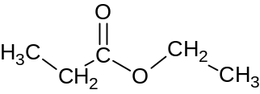  - Identify the family of organic compounds to which the above chemical belongs.  (b) Draw the structural formula and give the IUPAC name for one isomer of this compound.  (c) In an experiment to produce a sample of the organic compound X, a chemist refluxed a suitable reaction mixture for 1 hour. At this point, 5.00 x 10⁻³ moles of H⁺ ions remained in the reaction flask along with compound X. The chemist added excess sodium carbonate solution to remove the unwanted H⁺ ions.  Calculate the volume of carbon dioxide gas which would theoretically be produced from the addition of the sodium carbonate at 25ºC and 100kPa pressure. Show all working. | 1  2  2

Marks
Question 24 | (4 marks)

(a) Oxides of nitrogen (NO_{x}) play a role in the production of photochemical smog. A poisonous gas present in this smog is an allotrope of oxygen.  Identify this gas.  - Describe another environmental issue associated with increased levels of NO_{x} in the atmosphere. Include a chemical equation in your answer. | 1  3

Question 25 | (4 marks)

- Write a balanced chemical equation for the reaction occurring in the Haber process. |  |  | 1
- Explain why the rate, but not the yield, is increased when higher temperatures are used in the Haber process. |  |  | 3
Question 26 | (5 marks) | Marks

A chemical mixture of ionic salts is known to contain two of the following cations:  Ca²⁺; Ba²⁺; Cu²⁺; Pb²⁺; Fe²⁺  A student planned and followed the procedure, shown in the following flowchart, and identified the two unknown cations in a mixture.  mixture of two unknown cations  2M HCl (aq) added. A white solid formed.  HCl was added until precipitation ceased.  0.1 M H₂SO₄(aq) added to the same sample.  A white precipitate formed which gave a  lime-coloured flame in a flame test.  - Identify the cation responsible for the white precipitate formed upon addition of HCl. | 1
(b) Write a net ionic equation for the reaction which produced the white precipitate upon addition of H₂SO_{4.} | 1
- Justify the procedure the student followed to identify these two cations. | 3
Marks
Question 27 | (6 marks)

- Draw a Lewis electron dot diagram of ozone, and label the electrons in the coordinate covalent bond. | 2
- Assess the impact of ozone on human health. | 4

Marks
Question 28 | (4 marks)

A student carried out various water quality tests on samples of water from five different locations, labelled A - E. Their results are summarised in the table below.  - Identify the site (A to E) which may have been located next to farmland. Justify your answer.  - Identify which sample would be classified as the “hardest” and explain one impact that this would have on people using this water. | 2  2
   | A | B | C | D | E
  Turbidity (NTU) | 0.9 | 15.5 | 2.1 | 10.4 | 50.2
  pH | 7.4 | 8.6 | 7.0 | 7.2 | 6.9
  DO (ppm) | 9.2 | 6.0 | 6.8 | 6.5 | 6.8
  Phosphate (ppm) | 0.03 | 0.30 | 0.03 | 0.01 | 0.05
  Ca²⁺ (ppm) | 32 | 21 | 87 | 20 | 18

Section II
25 marks
Attempt ONE question from Questions 29 to 33
Allow about 45 minutes for this section.

Answer in a writing booklet. Extra booklets are available.

Show all relevant working in questions involving calculations.

Pages

Question 29 Industrial Chemistry ……………………………………………….20 - 21

Question 30 Shipwrecks, Corrosion and Conservation ………………………… 22 - 23

Question 31 Biochemistry of Movement ……………………………………….. 24 - 25

Question 32 The Chemistry of Art ……………………………………………… 26 - 27

Question 33 Forensic Chemistry ………………………………………………...28

Marks
Question 29---Industrial Chemistry (25 marks)

(a)  X (s)  Na₂CO₃ (aq)  lime dissolver  Ca(OH)₂  CaO  furnace  reaction tower  NaCl (aq)(aq)  ammonia absorber  heat  filter  heat  CO₂  CO₂  NH₄Cl  NaHCO₃  NaHCO₃  NH₄Cl  NH₃  CaCl₂ (s) | (i) | The Solvay process to produce sodium carbonate can be summarised in the form of a flow chart, such as the one shown below.  NH₃ dissolved in NaCl  Identify substance X in the flow chart above. | 1
 | (ii) | Explain TWO factors that need to be considered when choosing a site for a Solvay plant. | 3
 | (iii) | A manufacturer of sodium carbonate receives an order for 50.0 tonnes (5.0 x 10⁷ g) of the product.  Calculate the volume of a 12M NaCl solution required to produce this quantity of product. Include a balanced chemical equation with your answer.  Question 29 continues on page 21 | 3

Marks
Question 29 (continued)

(b) | (i) | During your practical work, you performed a first hand investigation to carry out saponification and test the major product of the reaction.  Outline the method you followed during this investigation. | 3
 | (ii) | Account for the cleaning action of soaps such as the one you produced in terms of the molecular structure of the soap. | 3

(c) | (i) | A series of reactions are involved in the production of sulfuric acid from elemental sulfur using the Contact process. Describe the reactions and justify the conditions and chemistry involved in the process. | 7

(d) | (i) | Contrast the basic function and the energy requirements of a galvanic and electrolytic cell. | 2
 | (ii) | Explain the significance of electrolysis to the production of sodium hydroxide, including a relevant equation with your answer. | 3

Marks
Question 30---Shipwrecks, Corrosion and Conservation (25 marks)

(a) | (i) | The diagram below shows how the inside of a cracked steel pipe may soon corrode if in contact with air and moisture.  Fe  cathodic  area  anodic area  e⁻  Fe²⁺  OH⁻  rust observed  Identify the oxidation state of iron in the rust observed on the inside of the pipe. | 1
 | (ii) | Explain how an underground steel pipe could be protected from corrosion using TWO suitable methods. | 3
 | (iii) | In the above diagram, oxygen is reduced in the presence of water. If the pipe was exposed to acidic conditions, oxygen may be reduced in the presence of H⁺ ions.  Compare the Eº produced by the Fe/Fe ²⁺reaction coupled with the reduction of oxygen under these two different conditions. Include equations and calculations in your answer.  Question 30 continues on page 23 | 3

Marks
Question 30 (continued)

(b) | (i) | During your practical work, you performed a first hand investigation to observe the effect of the concentration of a solution on the rate of its electrolysis.  Outline the method you followed, and describe your observations, for this investigation. | 3
 | (ii) | Account for any differences in the reaction products you observed during electrolysis when the solution was dilute and when it was concentrated. Include relevant equations with your answer. | 3

(c) | (i) | Assess factors that affect the extent of corrosion of metal structures and artifacts exposed to an aqueous environment as a result of a shipwreck. | 7

(d) | (i) | In the late 1700s, Galvani observed muscle contractions in a frog’s leg when its spinal cord was connected by copper hooks to an iron railing.  Contrast the inferences made by Galvani and Volta to explain the cause of these contractions. | 2
 | (ii) | Explain the significance of Volta’s work in the area of electron-transfer reactions. | 3
Marks
Question 31---The Biochemistry of Movement (25 marks)

(a) | (i) | The diagram below is a simplified description of the main steps in the metabolism of glucose to carbon dioxide and water.  water  TCA Cycle  glucose  pyruvic acid  Acetyl-CoA  X  P₂  P₁  Oxidative  Phosphorylation  oxygen  ADP + P  ATP  Identify the name of the process represented by letter ‘X’ in the above diagram. | 1
 | (ii) | Identify Products P₁ and P₂ formed in the TCA cycle and explain their role in the oxidative phosphorylation stage of the above process.  Question 31 continues on page 25 | 3
Marks
Question 31 (continued)

 | (iii) | Account for the production and effects of 2-hydroxypropanoic acid (lactic acid) in muscle cells. | 3

(b) | (i) | During your practical work, you performed a first hand investigation to observe the effect of changes in pH on the reaction of an enzyme.  Outline the method you followed during this investigation. | 3
 | (ii) | Account for any difference in the enzyme activity you observed in this investigation. | 3

(c) |  | Analyse the structure and role of triacylglycerols (TAGs) in maintaining human health. In your answer discuss problems associated with excessively high or low levels of these molecules. | 7

(d) | (i) | Outline the chemistry involved with the formation of a peptide bond. | 2
 | (ii) | Explain the factors which influence the shape of a protein. | 3
Marks
Question 32---The Chemistry of Art (25 marks)

(a) | (i) | The graph below shows the trend in the first 9 successive ionisation energies of an unknown element, X.

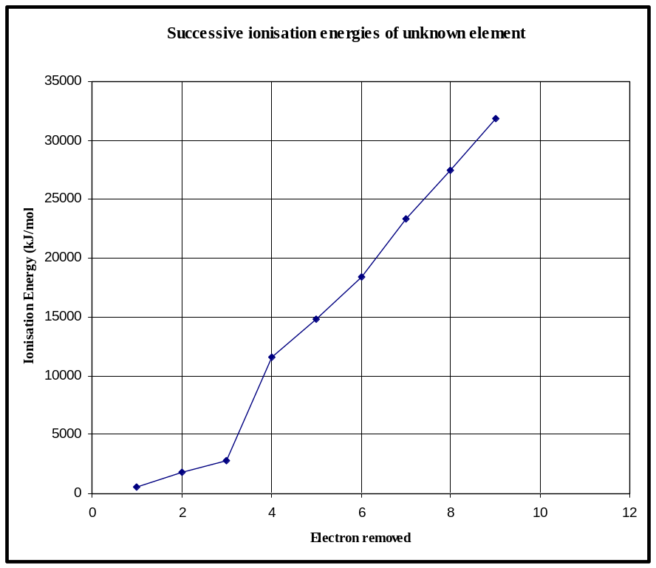

 | (i) | On the basis of the data above, identify the Group of the Periodic Table to which element ‘X’ belongs. | 1
 | (ii) | Explain how data of successive ionization energies can be used to predict the number of electrons in the outermost shell of an atom. Refer to your answer in (i) as an example. | 3
 | (iii) | In an appropriate manner, draw a labelled orbital-box diagram to show the arrangement of electrons in orbitals for an atom of phosphorus, and explain how the work of Pauli and Hund allowed you to predict the arrangement of electrons in this atom.  Question 32 continues on page 27 | 3

Marks
Question 32 (continued)

(b) | (i) | During your practical work, you performed a first hand investigation to demonstrate the oxidising strength of KMnO₄.  Outline the method you followed during this investigation. | 3
 | (ii) | Manganese is present in both potassium permanganate (KMnO₄) and manganese chloride (MnCl₂) but the metal is present in a different oxidation state in each compound.  Account for the difference in the oxidising strength of these compounds. | 3

(c) |  | The table below contains information about the colour of some solutions containing metal ions.

Metal ion | Colour of solution containing ion
Na⁺ | colourless
K⁺ | colourless
Mg²⁺ | colourless
Cu(H₂O)₆²⁺ | pale blue
Cu(NH₃)₄(H₂O)₂²⁺ | deep blue
Fe(H₂O)₆ ²⁺ | pale green
Fe(H₂O)₆³⁺ | yellow

 |  | Analyse factors which may affect the colour of chemicals containing metal ions, referring to data from the table as examples. | 7

(d) | (i) | Compare the features of element’s emission spectra to that of its absorption spectra. | 2
 | (ii) | Identify one current analytical technology and explain how it is used in the analysis of materials found in artworks. | 3

Question 33--- Forensic Chemistry (25 marks) | Marks

(a) | (i) | Analysis of a small chip of yellow paint found on a bicycle which was hit by a car was performed using emission spectroscopy. The emission spectrum for this sample is labelled X on the diagram below. The emission spectra of four metals are also shown on the diagram.

400 450 500 550 600 650 700 750 800
wavelength of spectral line (nm)
Ca
Sr
Cd
Na
X

(a) | (i) | Identify which of the above 4 metals was present in paint sample X. | 1
 | (ii) | Explain the origin of emission spectra and why each element exhibits its own characteristic spectrum. | 3
 | (iii) | Discuss a benefit and limitation of the use of emission spectra analysis in forensic chemistry. | 3

(b) | (i) | During your practical work, you performed a first hand investigation to carry out a distinguishing test for reducing and non-reducing sugars.  Outline the method you followed during this investigation. | 3
 | (ii) | Contrast the results of the test described for a reducing and non-reducing sugar and describe the chemical difference between these groups of sugars which provides the basis for this distinguishing test. | 3

(c) |  | Evaluate the use of chromatographic separation techniques in the work of the forensic chemist. | 7

(d) | (i) | Outline the structure and composition of DNA. | 2
 | (ii) | Explain problems associated with the use of DNA in forensic science. | 3

